LAB NO 04

Task 1: Write the Class + Constructor + Destructor

Copy the starter code below exactly into your file. This gives you the full class skeleton. Your only job in Task 1 is to implement the constructor and destructor as shown in Part 1.
Program:

#include <iostream>
using namespace std;

class MyVector {
private:
int* arr;
int size;
int capacity;
public:

MyVector() {
}
~MyVector() {

}
int getSize() { return size; }
int getCapacity() { return capacity; }
bool isEmpty() { return size == 2; }
void push_back(int value) {}
void pop_back() {}
int get(int index) { return -1; }
void set(int index, int value) {}
void insert(int index, int value) {}
void erase(int index) {}
void display() {}
};
int main() {
MyVector v;
cout << "Size: " << v.getSize() << endl;
cout << "Capacity: " << v.getCapacity() << endl;
cout << "Empty? " << v.isEmpty() << endl;
return 0;
}

Output:
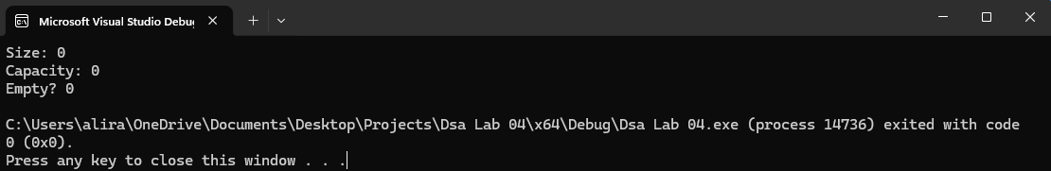
Task 2: Implement push_back and display

Implement push_back (add one element to the end) and display (print all elements). Use the algorithm from Part 1 Section 1.5.

What to Implement
- push_back(int value) — if full, double capacity and copy; then store value at arr[size] and increment size
- display() — loop from 0 to size-1 and print each element separated by spaces
Program:
#include <iostream>
using namespace std;

class MyVector {
private:
int* arr;
int size;
int capacity;

public:
MyVector() {
capacity = 2;
size = 0;
arr = new int[capacity];
}

~MyVector() {
delete[] arr;
}

int getSize() {
return size;
}
int getCapacity() {
return capacity;
}
bool isEmpty() { return size == 0; }

void push_back(int value) {

if (size == capacity) {
capacity *= 2;
int* newArr = new int[capacity];
for (int i = 0; i < size; i++) {
newArr[i] = arr[i];
}
delete[] arr;
arr = newArr;
}

arr[size] = value;
size++;
}

void display() {
for (int i = 0; i < size; i++) {
cout << arr[i] << " ";
}
cout << endl;
}

void pop_back() {}
int get(int index) { return -1; }
void set(int index, int value) {}
void insert(int index, int value) {}
void erase(int index) {}
};

int main() {
MyVector v;

v.push_back(10);
v.push_back(20);
v.push_back(30);

cout << "Elements: ";
v.display();

cout << "Size: " << v.getSize() << endl;
cout << "Capacity: " << v.getCapacity() << endl;

return 0;
}
Output:
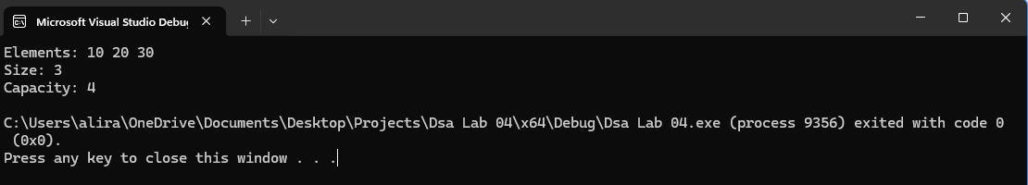
Task 3: Implement get and set

Implement get (read one element by index) and set (change one element by index). These work just like reading and writing an array slot.

What to Implement
- get(int index) — return arr[index]. If index is out of range (< 0 or >= size), print an error message and return -1.
- set(int index, int value) — store value into arr[index]. Check range first.
Program:
#include <iostream>
using namespace std;

class MyVector {
private:
int* arr;
int size;
int capacity;

public:
MyVector() {
capacity = 2;
size = 0;
arr = new int[capacity];
}

~MyVector() {
delete[] arr;
}

int getSize() {
return size;
}

int getCapacity() {
return capacity;
}

bool isEmpty() {
return size == 0;
}

void push_back(int value) {
if (size == capacity) {
capacity *= 2;
int* newArr = new int[capacity];

for (int i = 0; i < size; i++) {
newArr[i] = arr[i];
}

delete[] arr;
arr = newArr;
}

arr[size] = value;
size++;
}

void display() {
for (int i = 0; i < size; i++) {
cout << arr[i] << " ";
}
cout << endl;
}

int get(int index) {
if (index < 0 || index >= size) {
cout << "Error: Index out of range." << endl;
return -1;
}
return arr[index];
}

void set(int index, int value) {
if (index < 0 || index >= size) {
cout << "Error: Index out of range." << endl;
return;
}
arr[index] = value;
}

void pop_back() {}
void insert(int index, int value) {}
void erase(int index) {}
};

int main() {
MyVector v;

v.push_back(10);
v.push_back(20);
v.push_back(30);

cout << "Elements: ";
v.display();

cout << "Size: " << v.getSize() << endl;
cout << "Capacity: " << v.getCapacity() << endl;

cout << "Element at index 1: " << v.get(1) << endl;

v.set(1, 99);
cout << "After set: ";
v.display();

return 0;
}
Output:
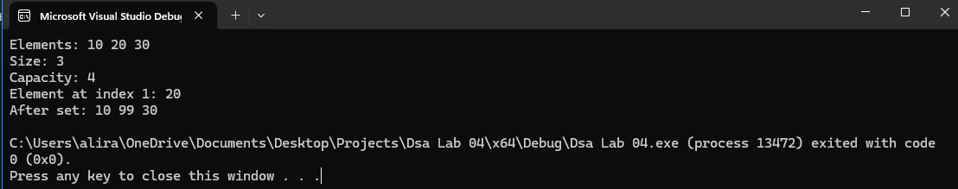
Task 4: Implement pop_back

pop_back removes the last element. This is the simplest of all operations — you do not need to move any elements or free memory. Simply decrease size by 1. But first check that the vector is not already empty.
What to Implement
- pop_back() — if size is 0, print an error. Otherwise just do size--.

Program:
#include <iostream>
using namespace std;

class MyVector {
private:
int arr[100];
int size;

public:
MyVector() {
size = 0;
}
void push_back(int value) {
arr[size] = value;
size++;
}
void pop_back() {
if (size == 0) {
cout << "Error: vector is empty" << endl;
return;
}
size--;
}
void display() {
cout << "Vector:";
for (int i = 0; i < size; i++) {
cout << " " << arr[i];
}
cout << endl;
}
};

int main() {
MyVector v;

v.push_back(10);
v.push_back(20);
v.push_back(30);
v.display();

v.pop_back();
v.display();

v.pop_back();
v.pop_back();
v.pop_back();

return 0;
}

Output:
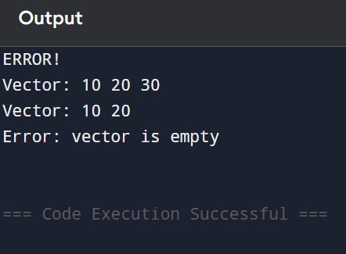
Task 5: Implement insert

insert adds a new element at a given position. To make room, every element from that position onwards must be shifted one step to the right. You must shift from right to left — shifting left to right would overwrite elements before they are moved.
Step-by-Step Algorithm
- Check if the vector is full. If so, double capacity (same as push_back).
- Check that index is valid (0 to size inclusive).
- Starting from the END, shift each element one position right until you reach index.
- Place the new value at arr[index].
- Increment size.
Program:
#include <iostream>
using namespace std;

class MyVector {
private:
int* arr;
int size;
int capacity;

public:

MyVector() {
capacity = 2;
size = 0;
arr = new int[capacity];
}

void push_back(int value) {
if (size == capacity) {
capacity *= 2;
int* newArr = new int[capacity];

for (int i = 0; i < size; i++) {
newArr[i] = arr[i];
}

delete[] arr;
arr = newArr;
}

arr[size] = value;
size++;
}
void insert(int index, int value) {

if (index < 0 || index > size) {
cout << "Invalid index\n";
return;
}
if (size == capacity) {
capacity *= 2;
int* newArr = new int[capacity];

for (int i = 0; i < size; i++) {
newArr[i] = arr[i];
}

delete[] arr;
arr = newArr;
}

for (int i = size; i > index; i--) {
arr[i] = arr[i - 1];
}

arr[index] = value;
size++;
}
void print() {
for (int i = 0; i < size; i++) {
cout << arr[i] << " ";
}
cout << endl;
}

~MyVector() {
delete[] arr;
}
};

int main() {
MyVector v;

v.push_back(10);
v.push_back(20);
v.push_back(30);

cout << "Before insert: ";
v.print();

v.insert(1, 99);

cout << "After insert: ";
v.print();
return 0;
}
Output:
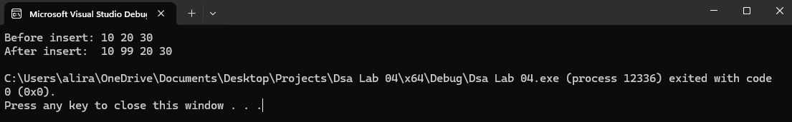
Task 6: Implement erase

erase removes the element at a given index. Every element after it must shift one position to the left to fill the gap. This is the opposite of insert — shift left to right.
Step-by-Step Algorithm
- Check that index is valid (0 to size-1).
- Starting from index, copy arr[i+1] into arr[i] for each position until the end.
- Decrement size.
Program:
#include <iostream>
using namespace std;

class MyVector {
private:
int* arr;
int size;
int capacity;

public:
MyVector() {
capacity = 2;
size = 0;
arr = new int[capacity];
}

void push_back(int value) {
if (size == capacity) {
capacity *= 2;
int* newArr = new int[capacity];
for (int i = 0; i < size; i++) {
newArr[i] = arr[i];
}
delete[] arr;
arr = newArr;
}
arr[size] = value;
size++;
}

void insert(int index, int value) {
if (index < 0 || index > size) {
return;
}

if (size == capacity) {
capacity *= 2;
int* newArr = new int[capacity];
for (int i = 0; i < size; i++) {
newArr[i] = arr[i];
}
delete[] arr;
arr = newArr;
}

for (int i = size; i > index; i--) {
arr[i] = arr[i - 1];
}

arr[index] = value;
size++;
}

void erase(int index) {
if (index < 0 || index >= size) {
return;
}

for (int i = index; i < size - 1; i++) {
arr[i] = arr[i + 1];
}

size--;
}

void print() {
for (int i = 0; i < size; i++) {
cout << arr[i] << " ";
}
cout << endl;
}

~MyVector() {
delete[] arr;
}
};

int main() {
MyVector v;

v.push_back(10);
v.push_back(20);
v.push_back(30);
v.push_back(40);

v.print();

v.insert(2, 99);
v.print();

v.erase(1);
v.print();

return 0;
}
Output:
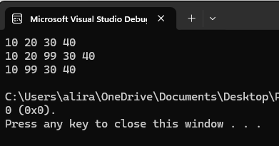

Task 7: Final Practice — Putting It All Together

Now use your complete MyVector class to solve the following exercises. Write each one separately in main() and verify your output matches.

Exercise A — Build and Modify a List
Create a vector, add numbers 1 through 6, then perform the following operations in order and display the result after each step:
- Display the original vector
- Insert the value 99 at index 2
- Remove the element at index 4
- Change the last element to 0 using set
- Display the final vector and its size

Program:
#include <iostream>
using namespace std;

class MyVector {
private:
int* arr;
int size;
int capacity;

public:
MyVector() {
capacity = 2;
size = 0;
arr = new int[capacity];
}

void push_back(int value) {
if (size == capacity) {
capacity *= 2;
int* newArr = new int[capacity];
for (int i = 0; i < size; i++) {
newArr[i] = arr[i];
}
delete[] arr;
arr = newArr;
}
arr[size] = value;
size++;
}

void insert(int index, int value) {
if (index < 0 || index > size) {
return;
}

if (size == capacity) {
capacity *= 2;
int* newArr = new int[capacity];
for (int i = 0; i < size; i++) {
newArr[i] = arr[i];
}
delete[] arr;
arr = newArr;
}

for (int i = size; i > index; i--) {
arr[i] = arr[i - 1];
}

arr[index] = value;
size++;
}

void erase(int index) {
if (index < 0 || index >= size) {
return;
}

for (int i = index; i < size - 1; i++) {
arr[i] = arr[i + 1];
}

size--;
}

void set(int index, int value) {
if (index < 0 || index >= size) {
return;
}
arr[index] = value;
}

int getSize() {
return size;
}

void print() {
for (int i = 0; i < size; i++) {
cout << arr[i] << " ";
}
cout << endl;
}

~MyVector() {
delete[] arr;
}
};

int main() {
MyVector v;

for (int i = 1; i <= 6; i++) {
v.push_back(i);
}

v.print();

v.insert(2, 99);
v.print();

v.erase(4);
v.print();

v.set(v.getSize() - 1, 0);

v.print();
cout << v.getSize() << endl;

return 0;
}
Output:
